**Deep learning features: CNN**

Deep learning provide various techniques to automatically get features from time-series and images.

For time-series there is LSTM to automatically do featurization

For images there is CNN to automatically do best featurization and CNN provides best featurizations then other techniques use to get features of images.

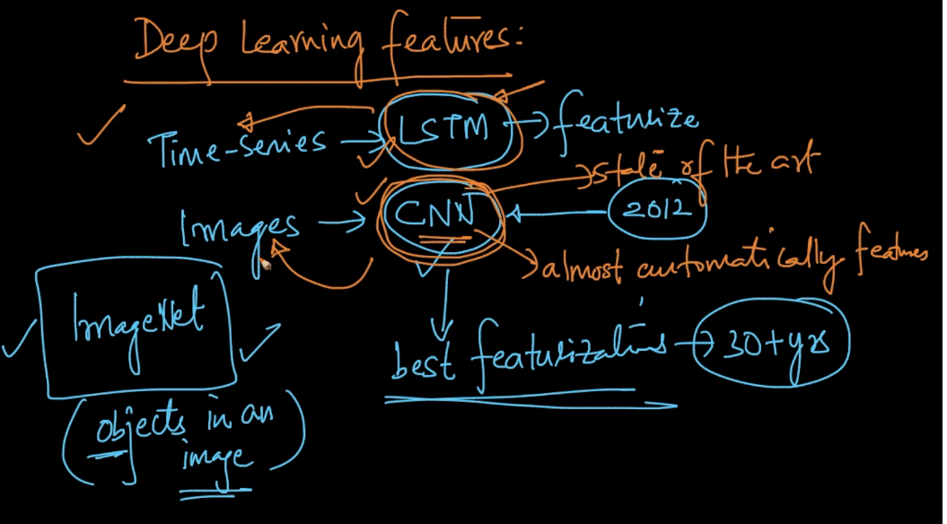

For example we provide a lot of x-ray images to CNN to determine whether tumor or not.

Designing CNN is much faster than decades of research

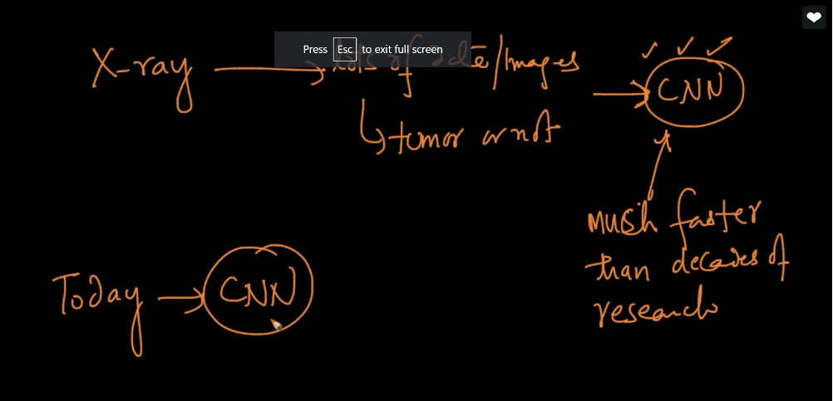

Comments :

Why we don’t use deep learning for every problem?

Because deep learning doesn’t provide interpretability and also not fast therefore we cannot use in low latency applications.